

**Computer Networks Lab 8**



**Name:Muhammad Shaheer.**

**Roll No:20p-0480**

NATIONAL UNIVERSTIY OF COMPUTER AND EMERGING SCIENCES, FAST- PESHAWAR CAMPUS Department of Computer Science & Software Engineering

Task 1:

1. Server Configuration:

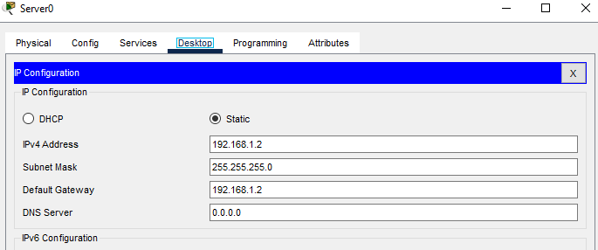

1. Make pool of network

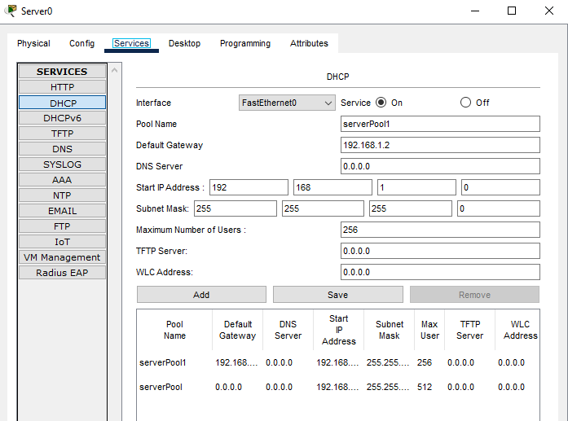

1. Now check topology and and remove already built in card by drag and drop and insert wireless interface card WPC300N

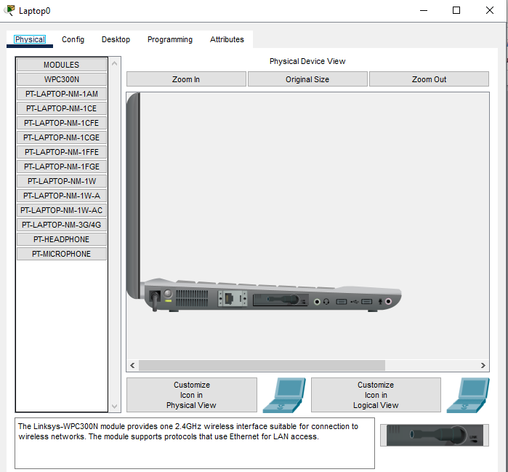

1. Now check topology and it will wirelessly connected with each other

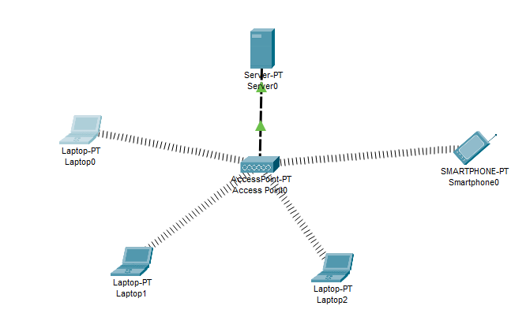

1. Now check DHCP request of all laptops whether its successful or not

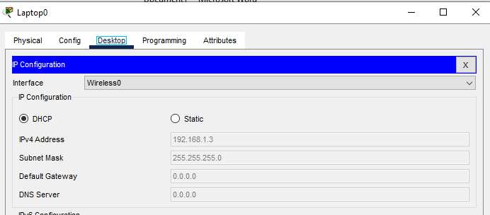

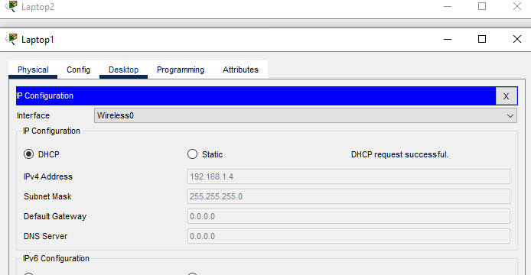

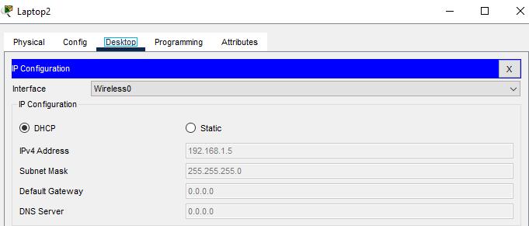

1. So topology was successfully implemented.

______________________________________________________________________________

Task 2:

Wireless Router configuration in Cisco Packet Tracer

Make topology like this:

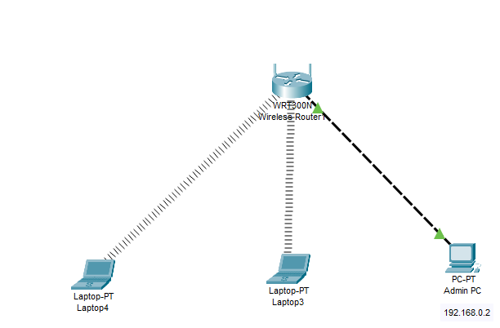

Now assign IP to admin pc

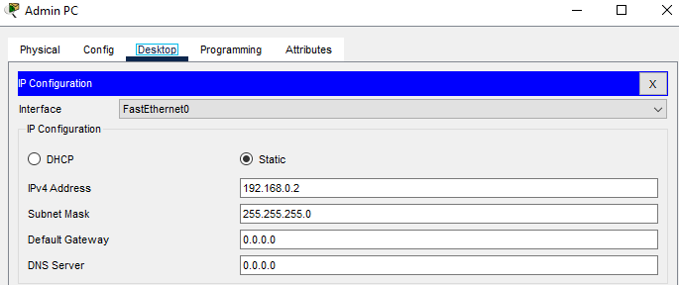

Now go to pc browser and access wireless router

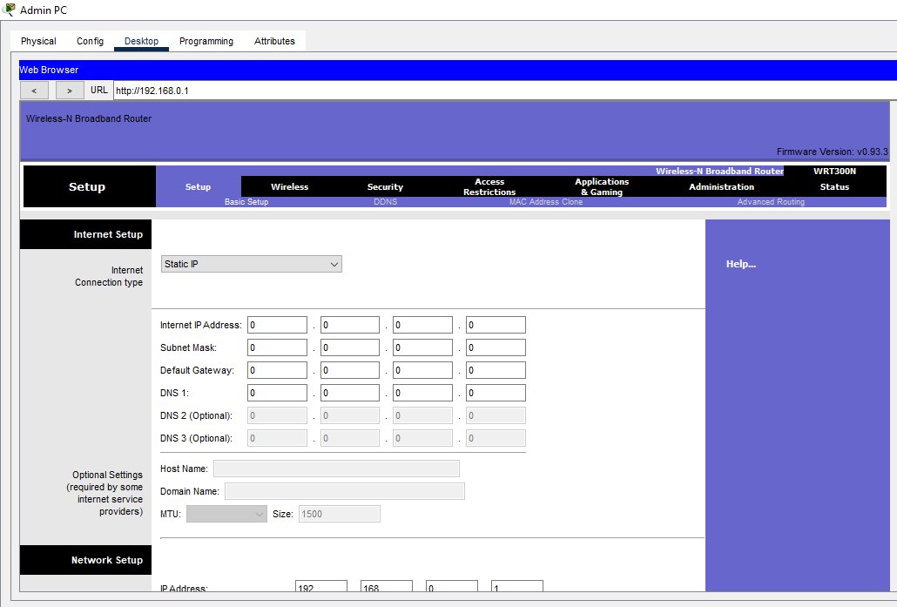

Now change password

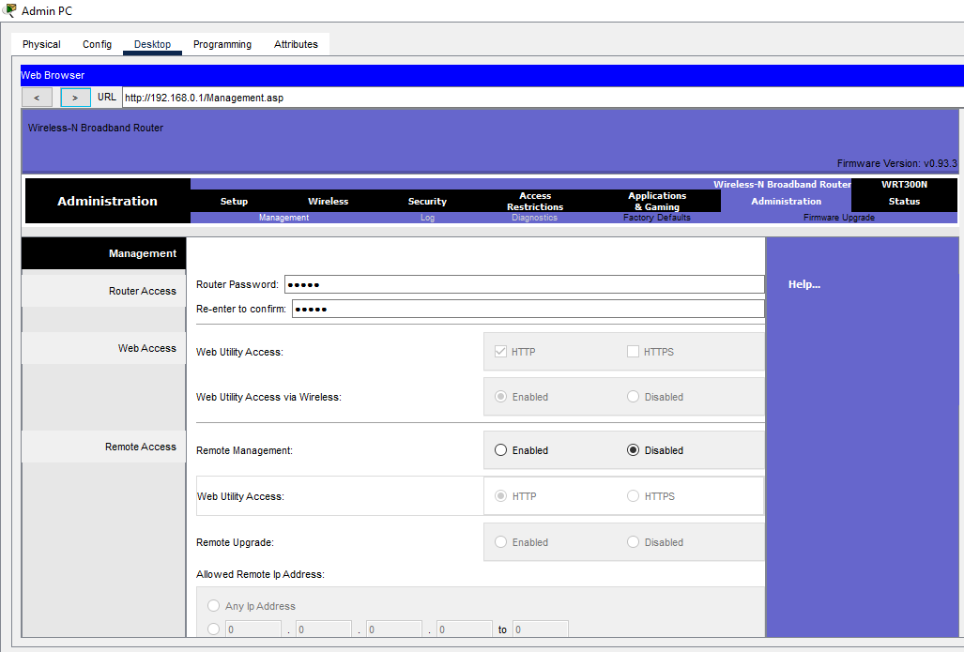

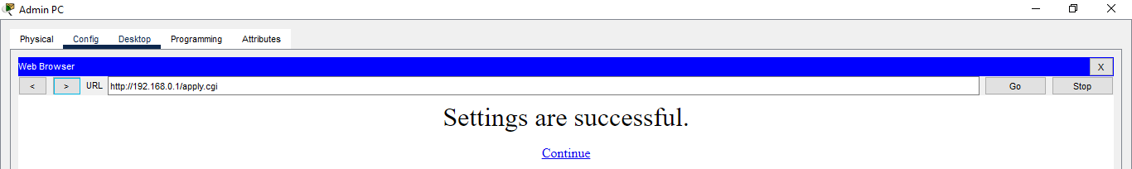

Setting LAN

Configure DHCP Pool



Note

Due to this error not be able to proceed

I tried to resolve this error and also discuss it with instructor bu t due to busy schedule not be able to resolved but I think it’s a technical issue so that’s why not be able to proceed with this task.